**URGENT MEDICAL DEVICE CORRECTION**

**Biofinity Toric Multifocal / Biofinity XR Toric contact lenses**

[ABB-CA]

Dear [Name],

CooperVision is voluntarily conducting a recall for certain lots of Biofinity Toric Multifocal / Biofinity XR Toric contact lenses from the USA market, effective immediately.

Our records indicate that you may have purchased a product from the following affected lot(s):

BIOFINITY TORIC MULTIFOCAL 6PK:

Lot # RB0687665

Lot # RB0687693

Lot # RB0687904

Lot # RB0687908

Lot # RB0687910

Lot # RB0687922

Lot # RE0154095

BIOFINITY XR TORIC 6PK:

Lot # RE0154100

Lot # RE0154103

Lot # RE0154105

Lot # RE0154107

Lot # RE0154113

Lot # RE0154114

Lot # RE0154117

COMFILCON A TORIC MFOCAL 1PK:

Lot # RC1768221

Lot # RC1768226

Lot # RC1768273

Lot # RC1768274

Lot # RC1768276

Lot # RC1768281

Lot # RC1768299

Lot # RC1768313

Lot # RC1768314

Lot # RC1768315

Lot # RC1768316

Lot # RC1768319

Lot # RC1768321

Lot # RC1768323

Lot # RC1768327

Lot # RC1768328

COMFILCON A XR TORIC 1PK:

Lot # RD0228465

Lot # RD0228595

Lot # RD0228598

Lot # RD0228603

Lot # RD0228606

Lot # RD0228607

CooperVision internally identified lot(s) that may contain lens blisters (packaging) with an incomplete or leaking seal resulting in a potentially unsterile condition. Consumers who have received Biofinity Toric Multifocal / Biofinity XR Toric lenses from the affected manufacturing lot(s) may experience adverse reactions up to and including ocular infection, should they not detect the seal integrity failure and the lens becomes unsterile prior to use.

There have been no adverse events associated with these lots as of 27 June 2025.

We request you take the following actions:

* 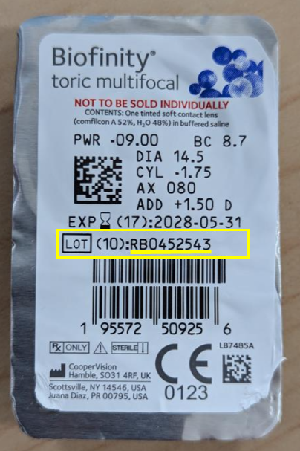Please examine any remaining lenses in your possession. The lot number can be found on the back panel of the carton below the expiration date, or on the front of the blister label below the expiration date. Below is an example of where to locate the lot number on a carton or blister.

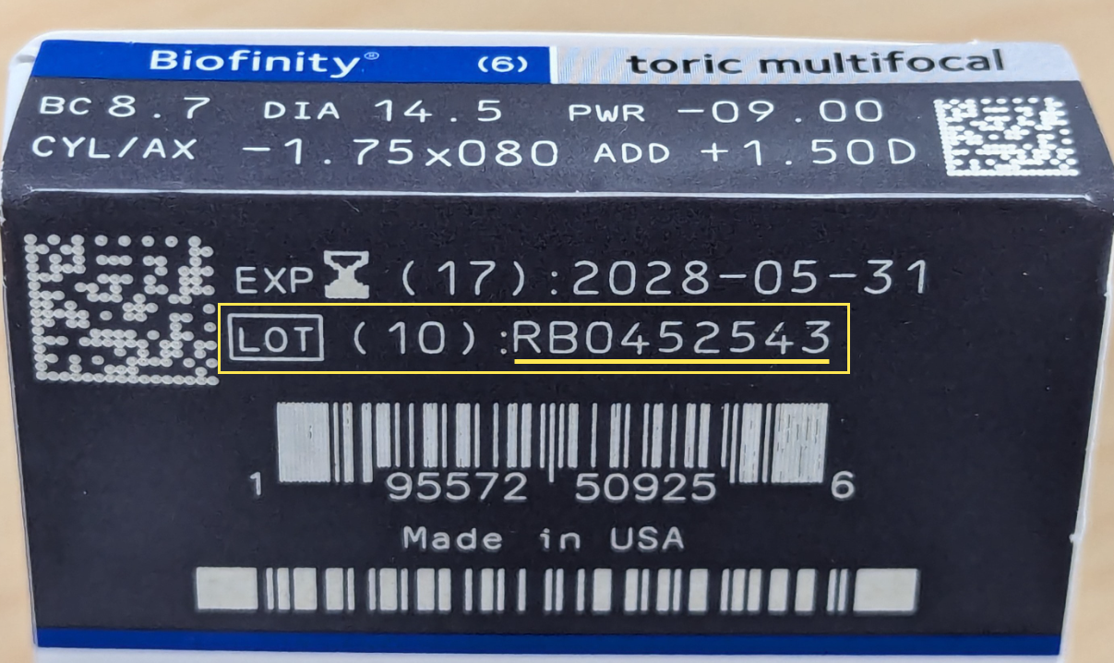

* If you locate any of the affected product, we recommend you return the affected product to our office at the address below for credit and/or replacement.
* Adverse reactions or quality problems experienced with the use of this product may be reported to the FDA’s MedWatch Adverse Event Reporting Program, either online, by regular mail, or by fax.]
* [ECP Office Information]

We apologize for any inconvenience. Should you wish to discuss this action, please contact the CooperVision Customer Care Team at 855-526-6737, 9:00 AM – 5:00 PM ET, Monday – Friday.

Yours sincerely,

Eye Care Practitioner